Foundation Case Study

Scenario: Streamline Solutions Inc. - Optimizing Software Deployment

Problem Statement: Implementing a Seamless CI/CD Workflow for a Spring Boot Application using Azure Boards, Azure, Git, Maven, Docker, Github, Github Actions

TASK 1: Project Management Setup

The azure board was established to manage the agile progress. Firstly, an epic was created with the name Java Spring Boot Application. Then a feature and user story were created for the deployment of the application. They were put in iteration 1. Then they were connected according to the relation like Epic -> Feature -> User Story. Then 9 tasks were created for the following user story.

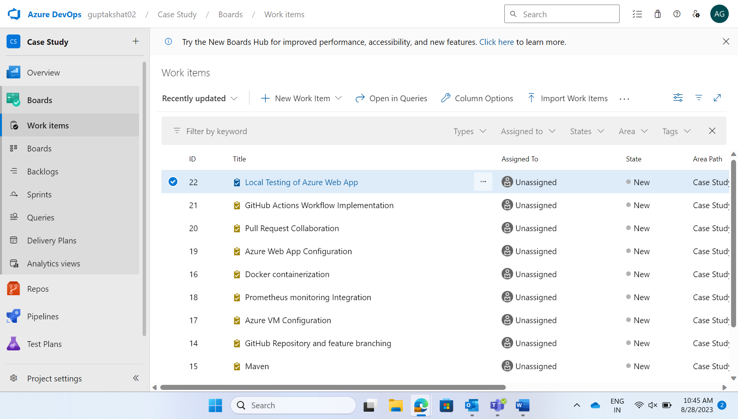

Sprint/Iterations -

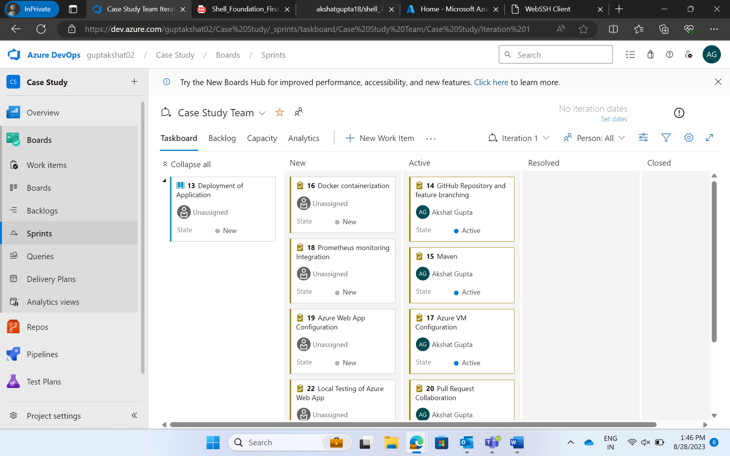

TASK 2: GitHub Repository and Feature Branching

The main GitHub repository was forked into the personal GitHub/local environment. Feature branches was created to work on specific tasks related to the application.

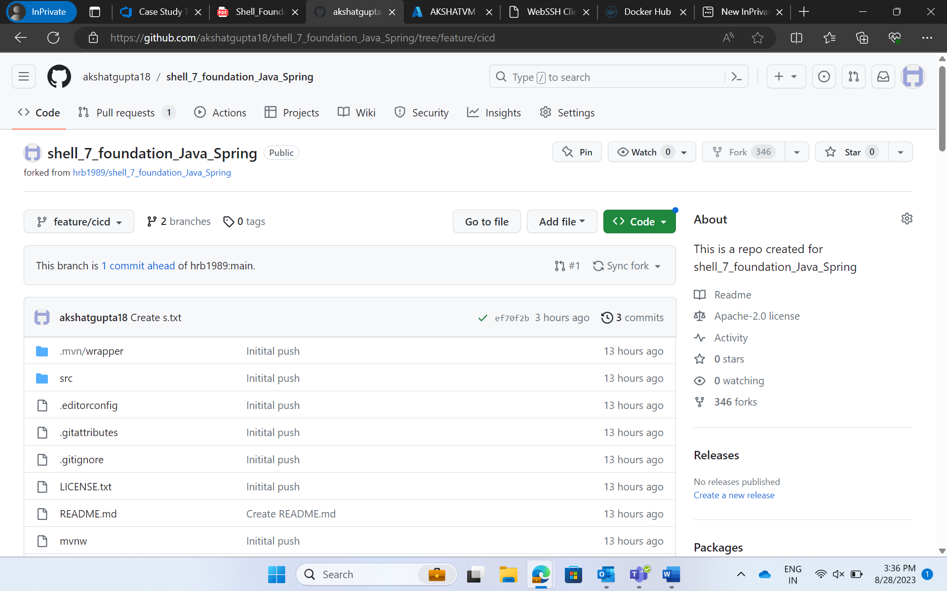

TASK 3: Azure VM Configuration

A virtual machine was configured and created on Azure with specific performance and resource specifications like Respective Location, Resource Group, B2s, Ubuntu, Username, Password, Standard HDD, Basic Dynamic Public IP to accommodate the development needs.

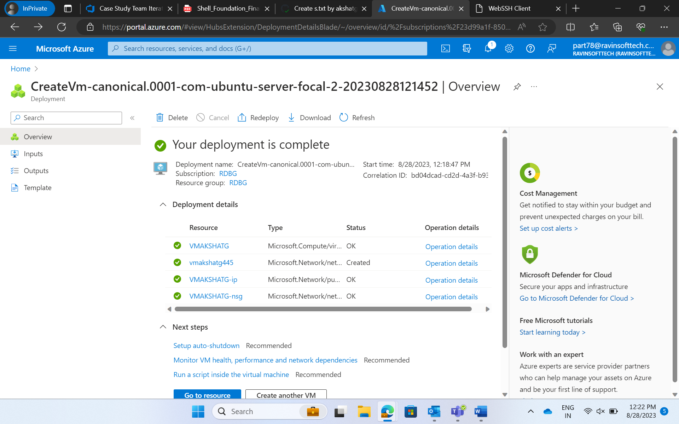

Steps to Connect

Step 1: Go to ssheasy.com.

Step 2: Enter IP Address

Step 3: Username

Step 4: Enter Password

Upgrading to java 17

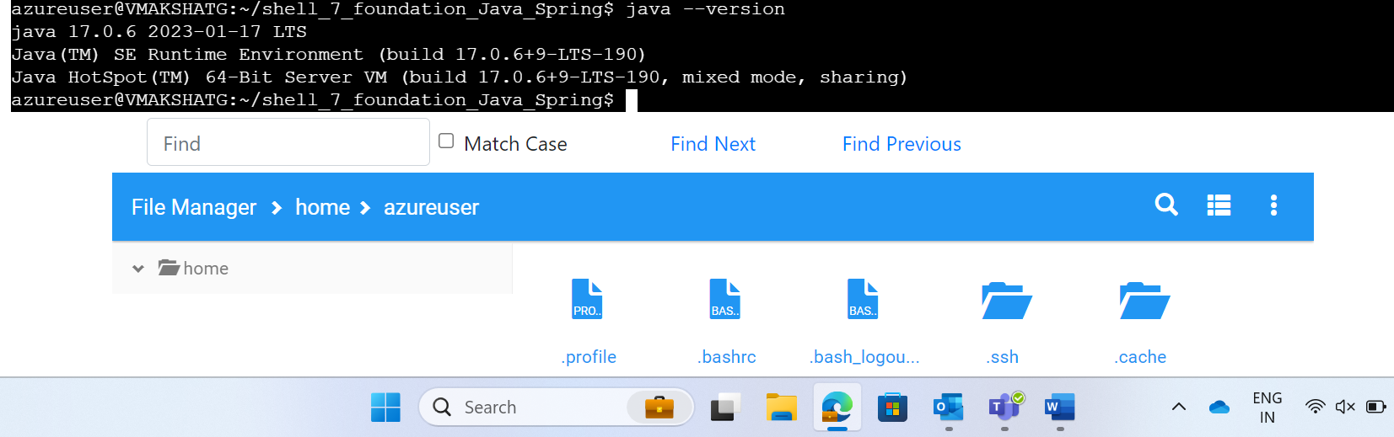

TASK 4: Maven – Based Build Process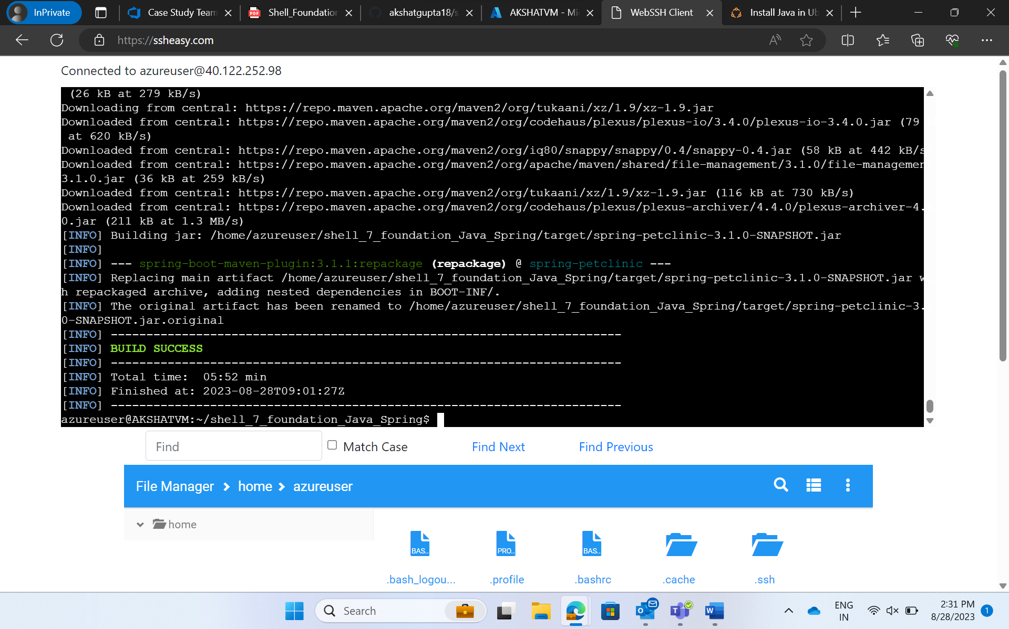

Jar files exists after running “mvn package”

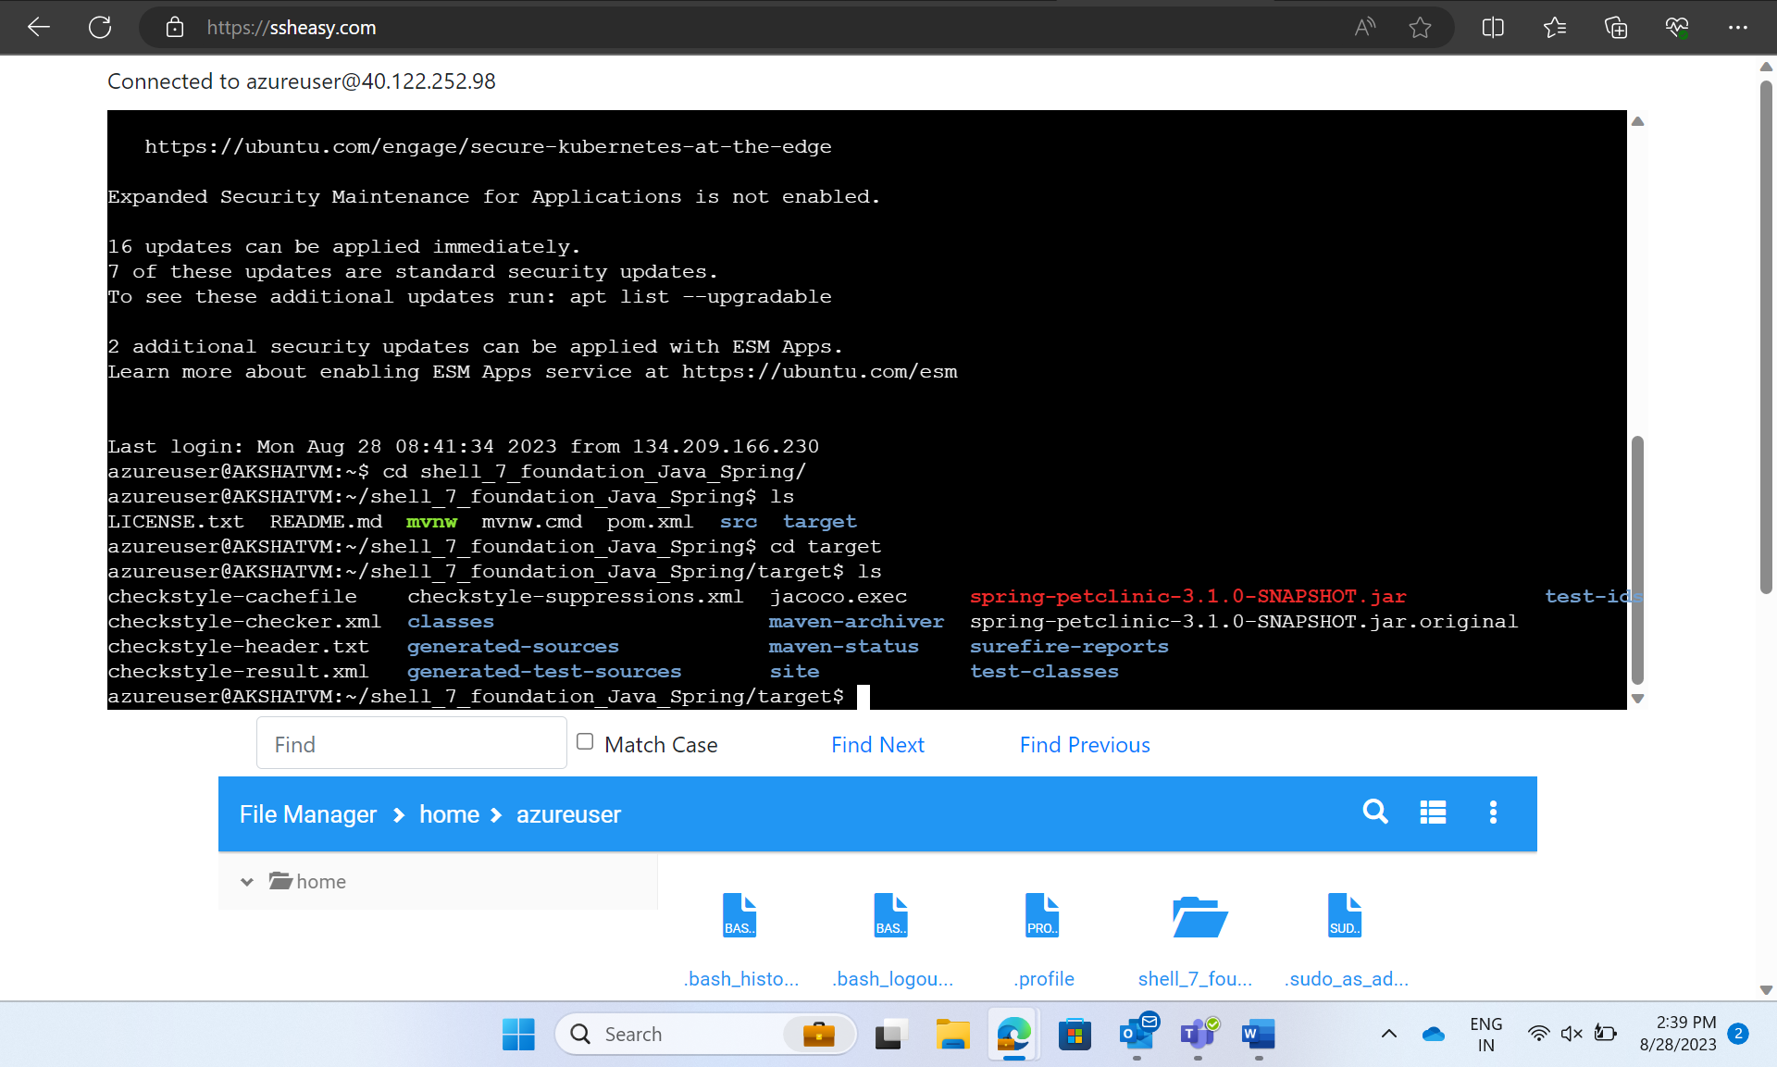

TASK 5: Prometheus Monitoring Integration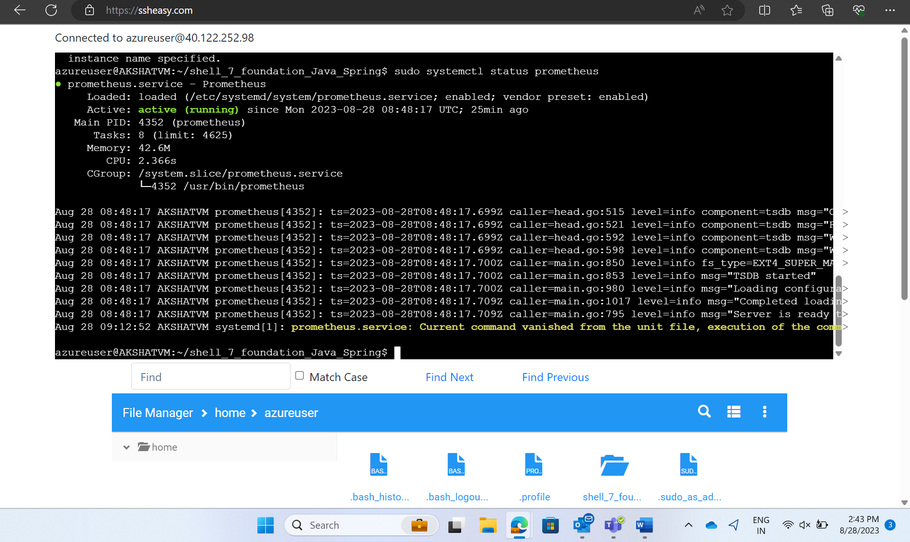

TASK 6: Docker Containerization

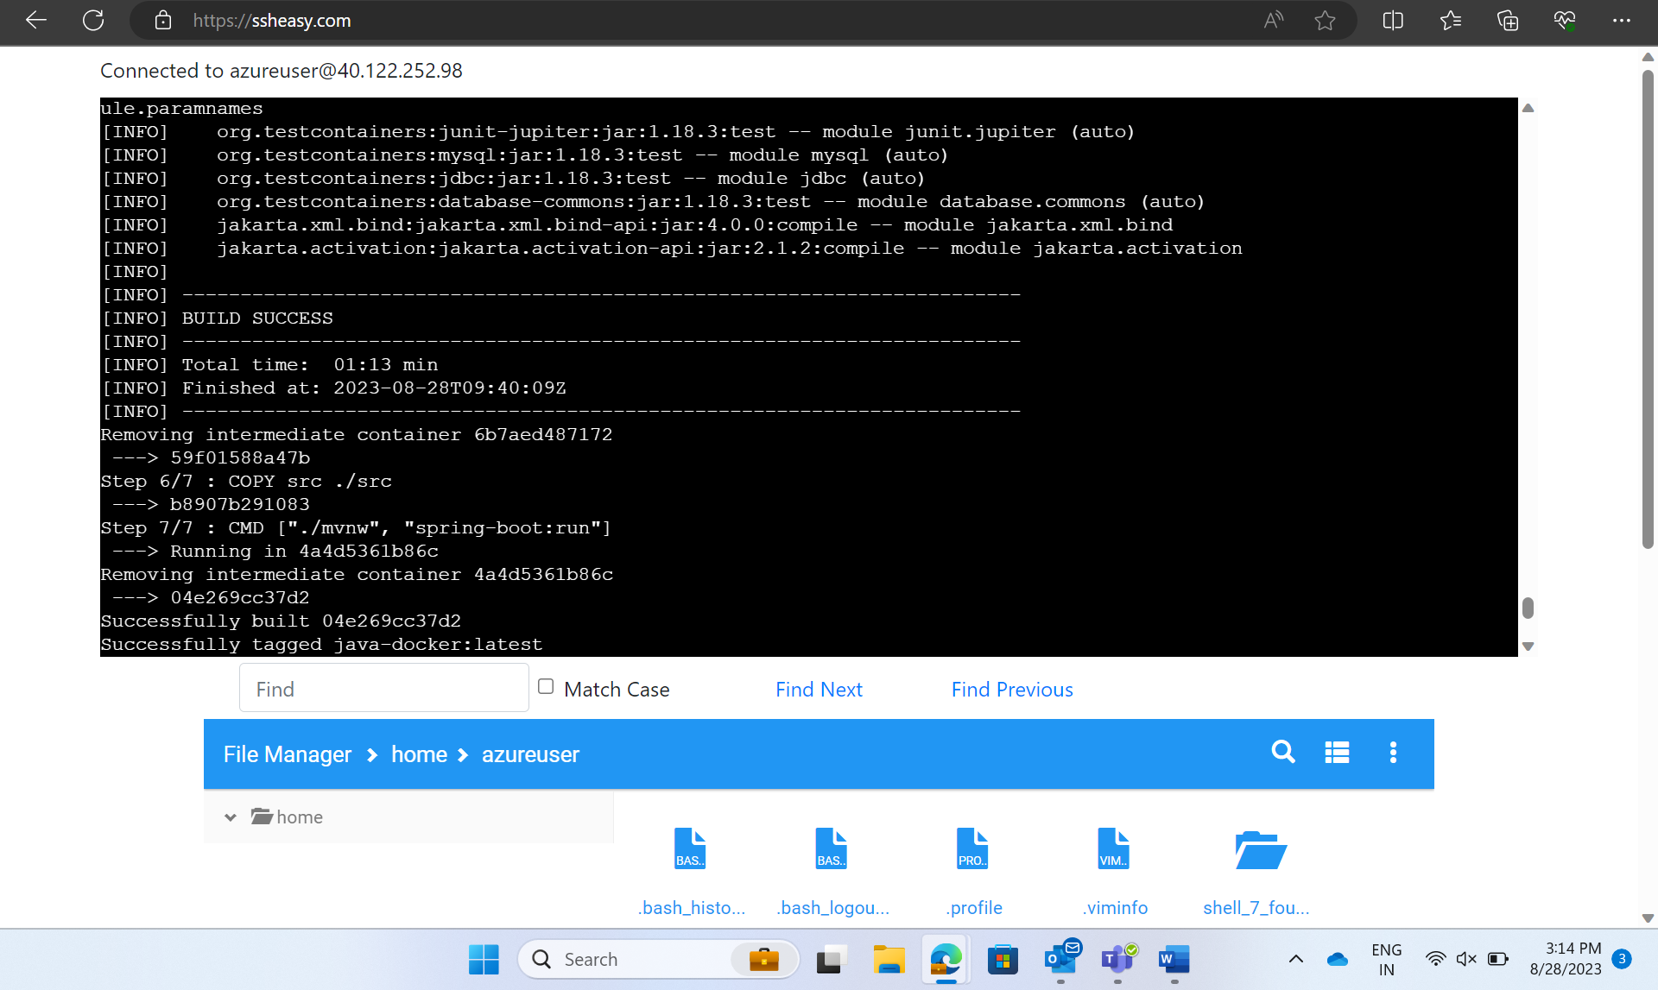

Docker images

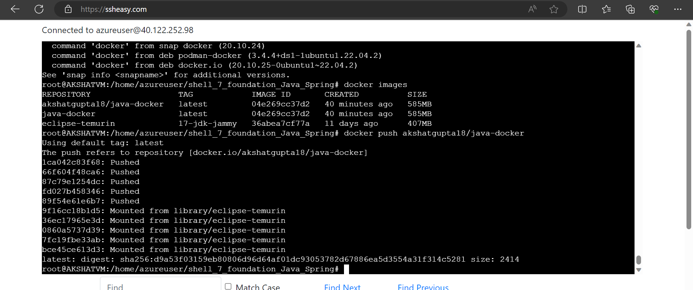

TASK 7: GitHub Actions Workflow Implementation

Creating workflow.yaml file-

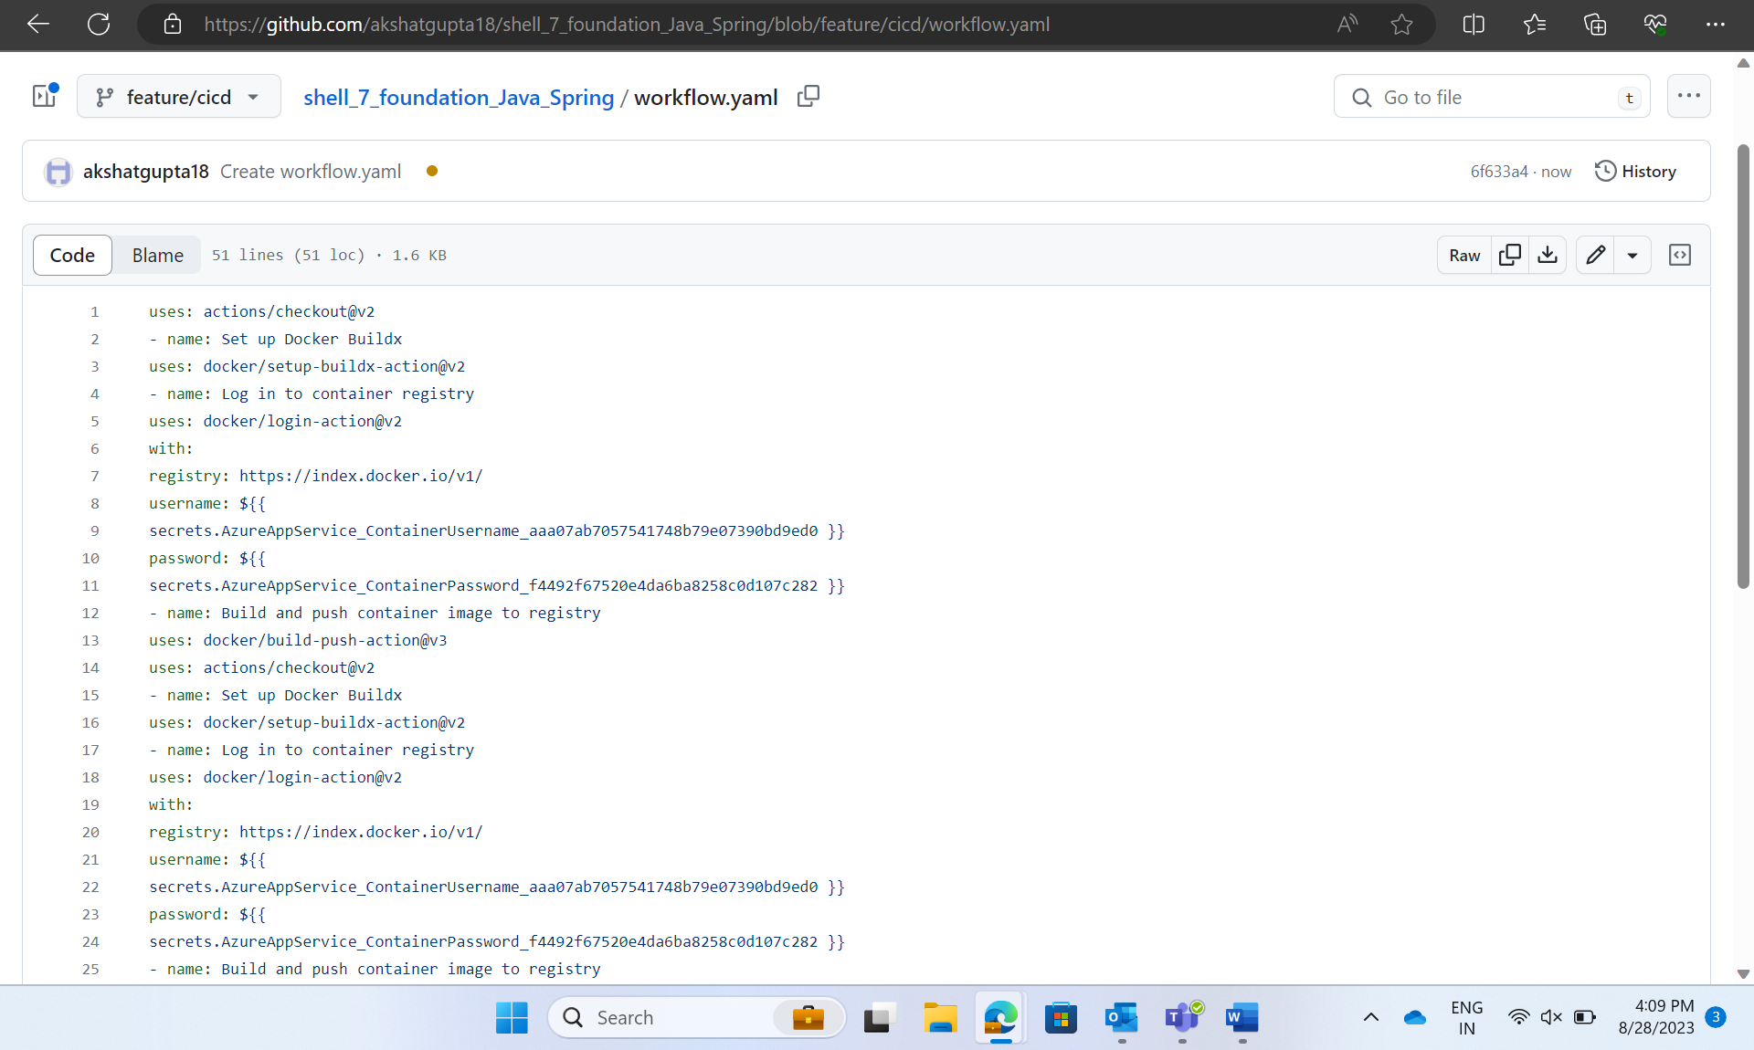

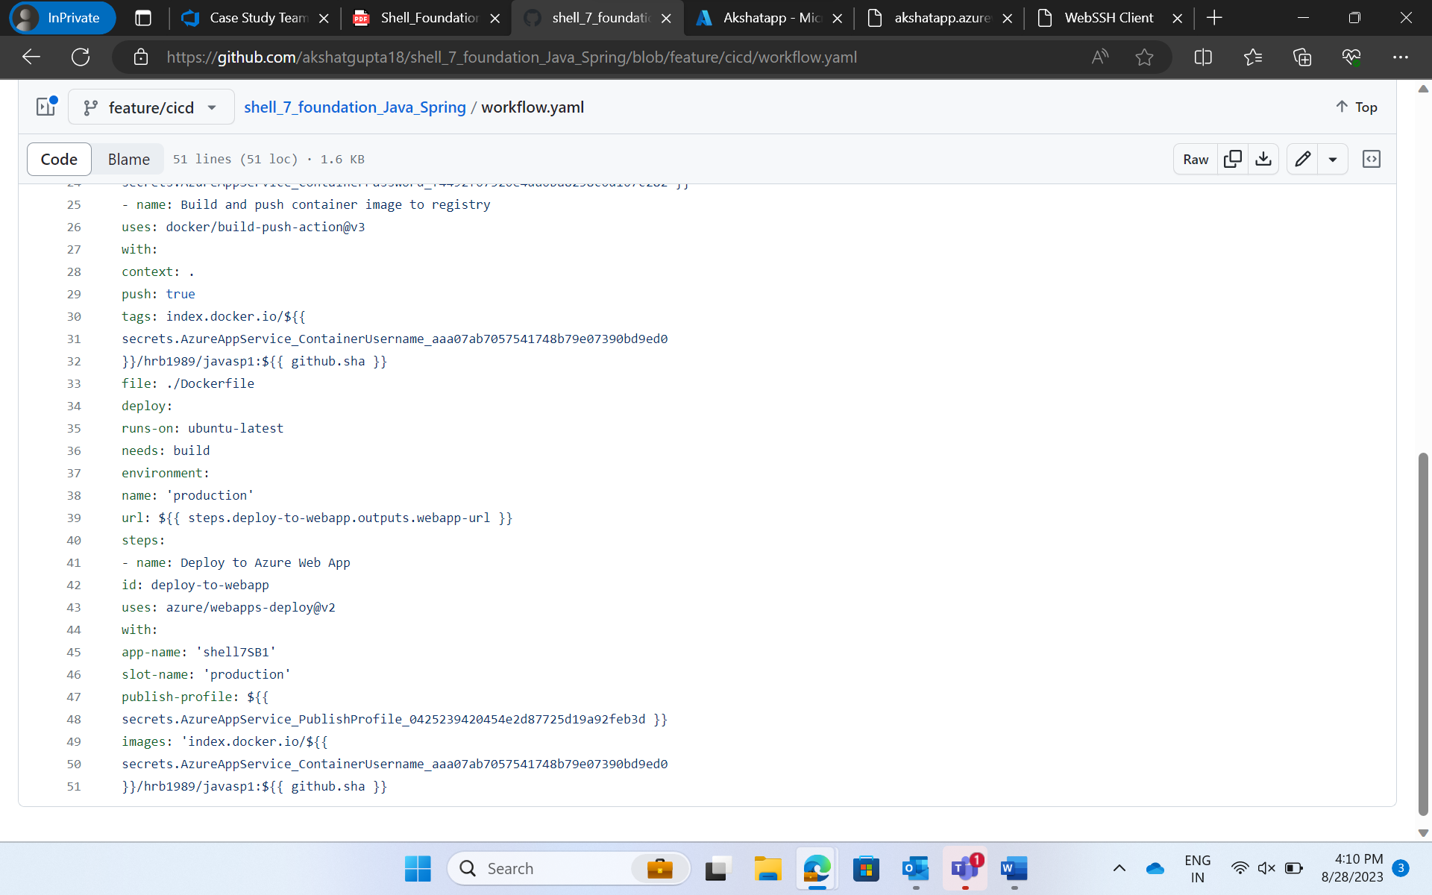

Running the build -

In the Repository,

Step 1: Went to Settings

Step 2: Selected Pages from Left Navigation

Step 3: Selected branch as “feature/cicd”

Step 4: Save

Step 5: Went to Actions from horizontal Nav Bar

Step 6: Clicked on the workflow to view.

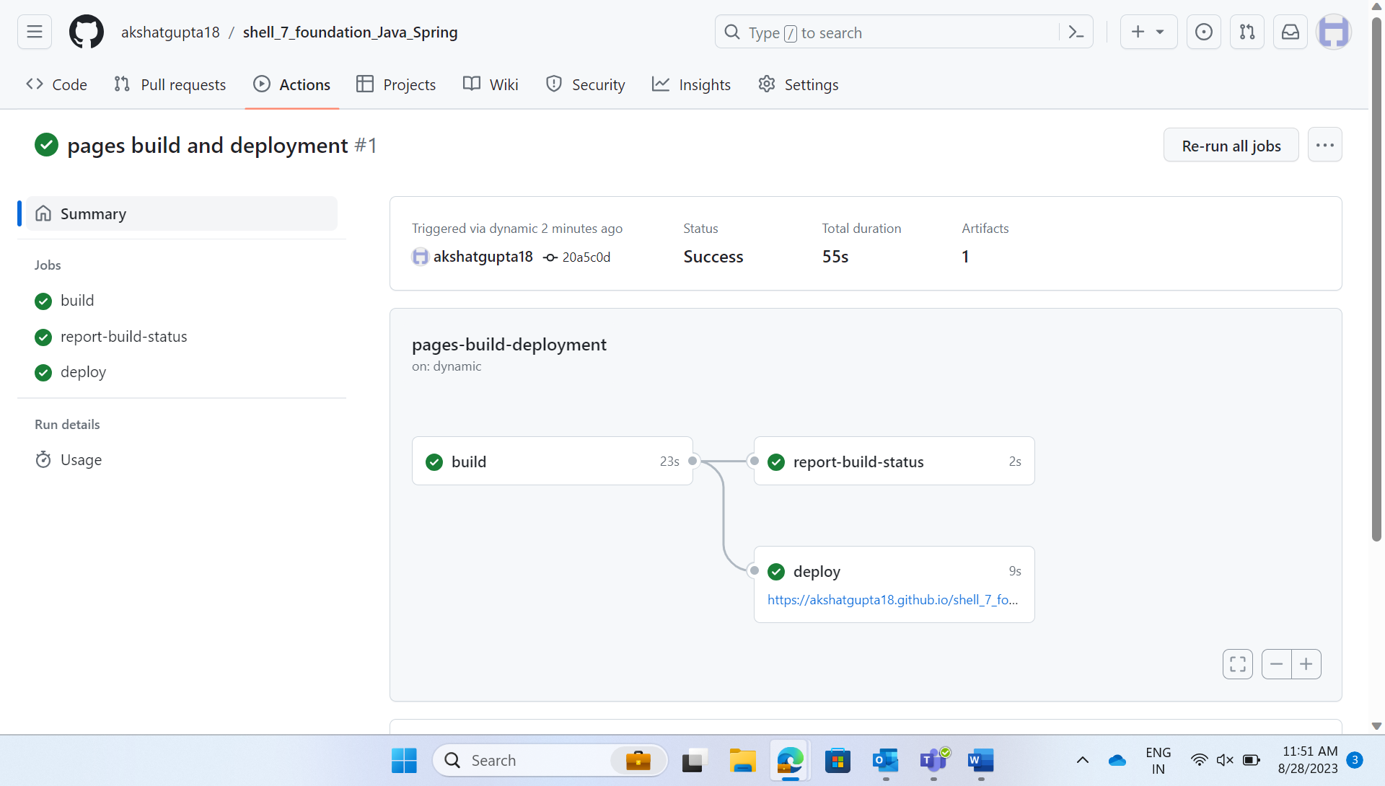

After changes –

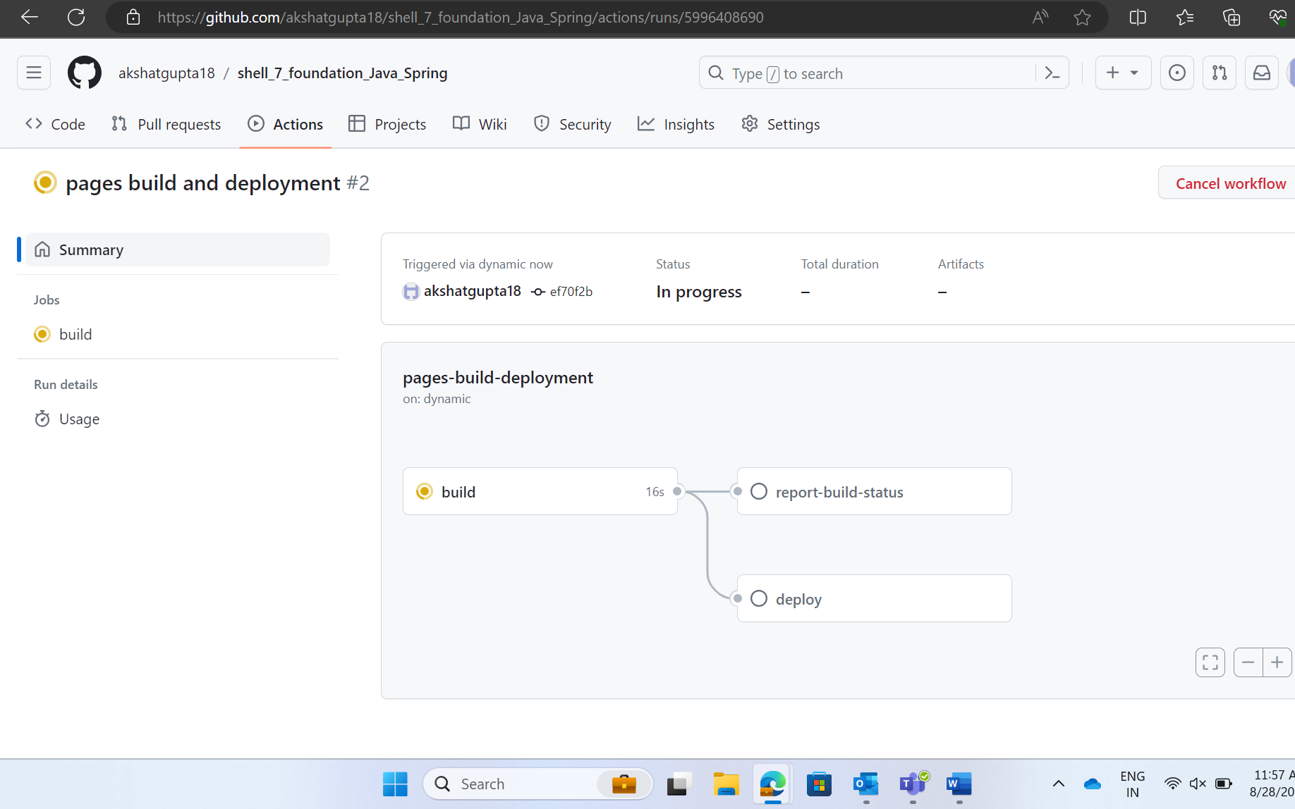

Pull request -

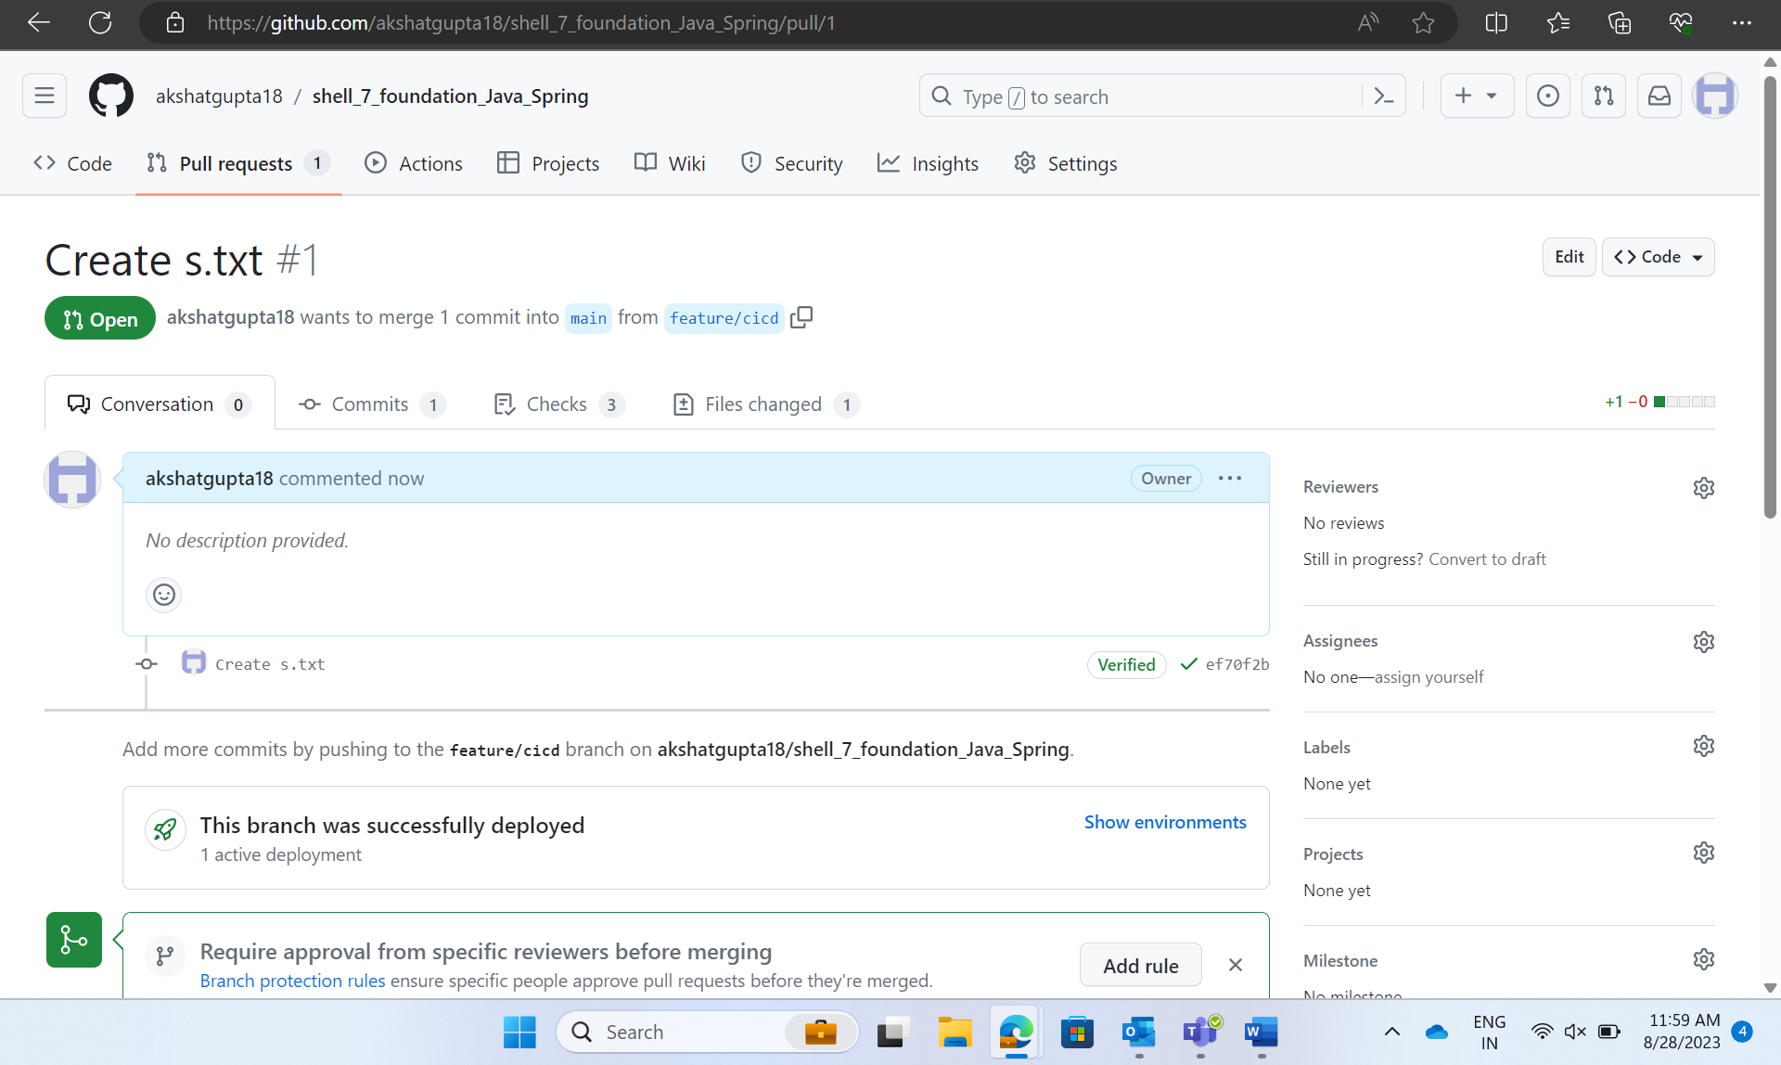

Task 8 - Azure Web App:

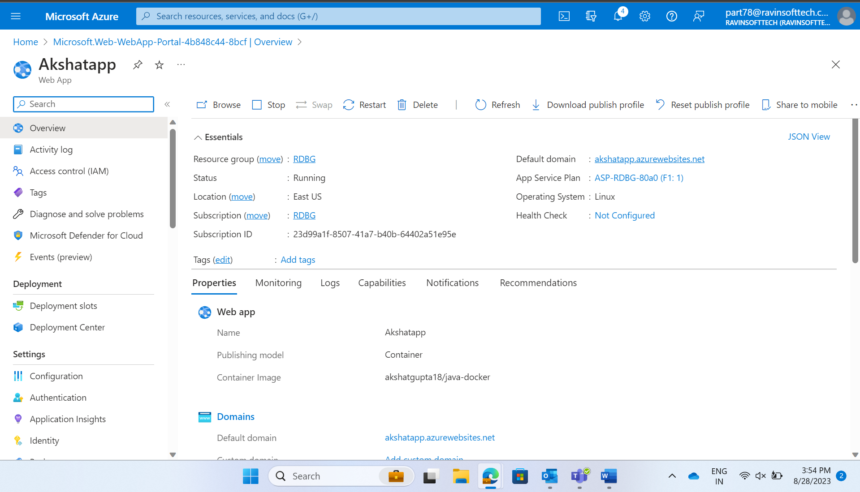

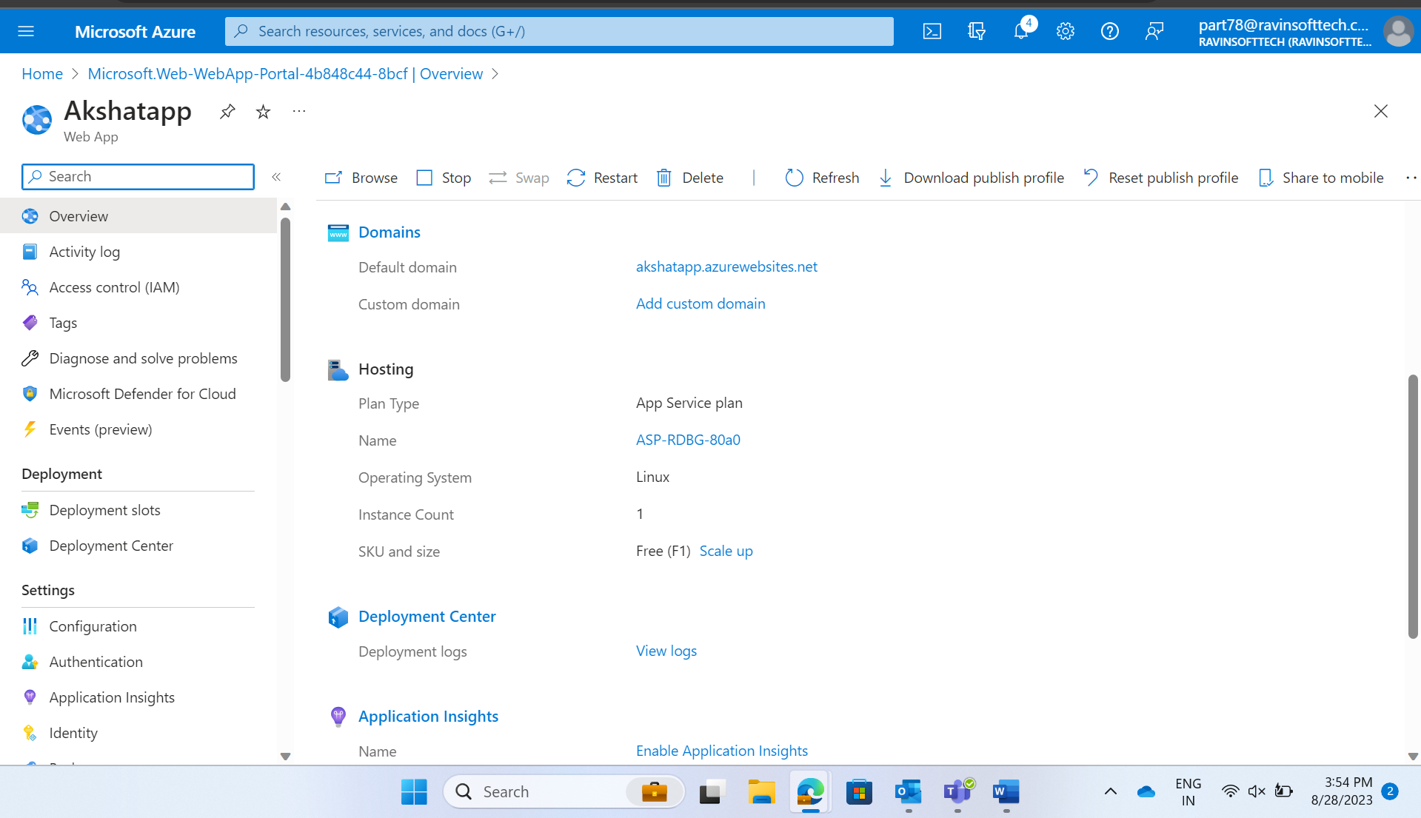

Test case –

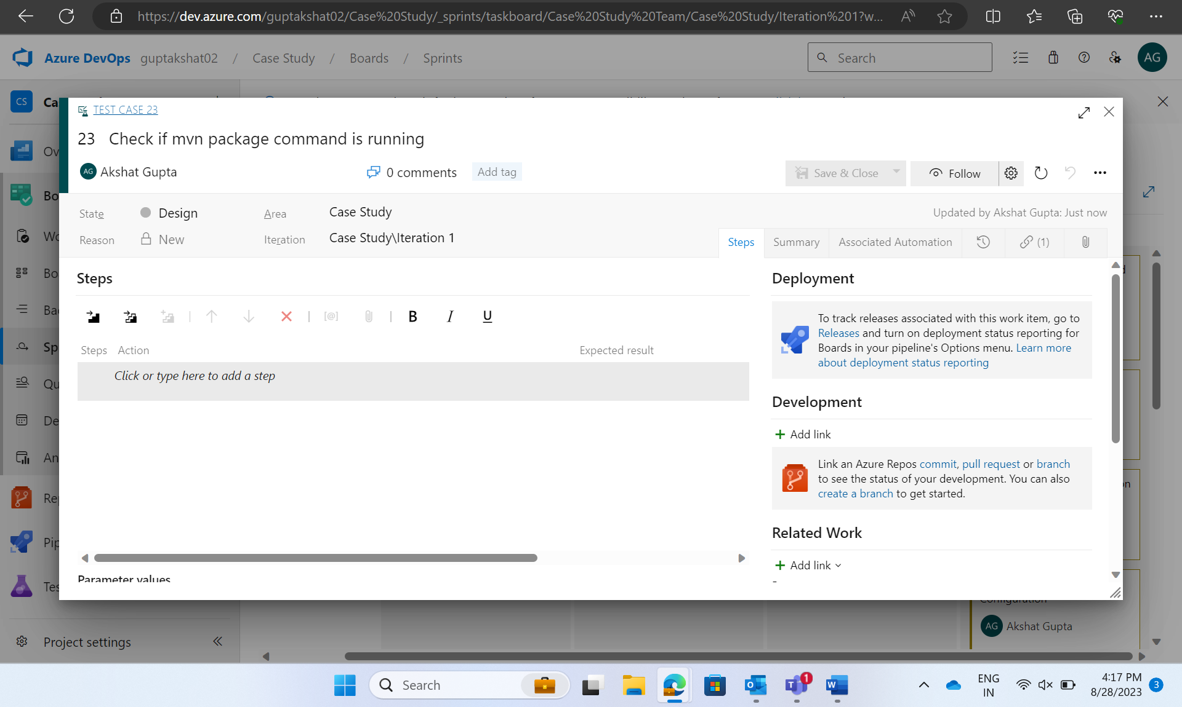

Task 9 – Azure Boards Task and Sprint Closure:

